**Bergelson, Dovid (August 12th, 1884 – August 12th, 1952)**

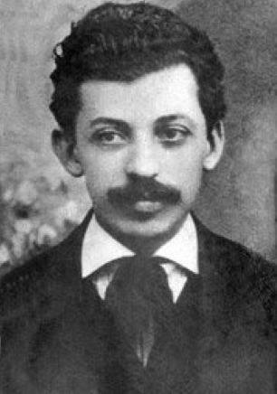

Dovid Bergelson around 1910

Dovid Bergelson was a major Yiddish prose writer and essayist. He had a lasting impact on Yiddish fiction writing, introducing new narrative techniques such as free indirect discourse. He brought literary creation in Yiddish to new heights, appropriating the language for the purposes of an Impressionist, high literary style. He was also a prolific essayist, committed to the notion of the social role of the writer, and to the ideals of Yiddishism, the creation of a new secular Yiddish culture in the name of a Jewish national project rooted in Eastern Europe and distinct from Zionism. These political ideals partly explain Bergelson’s conversion to Soviet state socialism in 1926: in his view, the Soviet Union was the only place compatible with the Yiddishist project. He settled there permanently in 1934. His later literary production radically differed from his earlier writings, and conformed to the doctrine of Socialist Realism. In 1942, he joined the Jewish Anti-Fascist Committee, supporting the Soviet war effort against Nazi Germany. After the war, Stalin turned against the Committee: Bergelson was arrested in 1949, then executed on August 12th, 1952 together with twelve other Jewish writers and intellectuals.

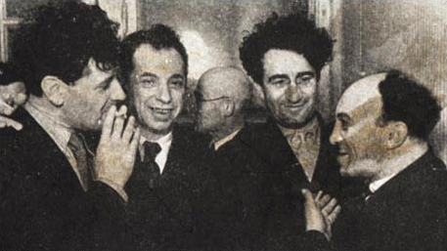

(from left to right): Soviet Yiddish poets Peretz Markish, Dovid Bergelson, Izi Kharik, and actor Solomon Mikhoels in Moscow in 1937. Markish, Bergelson, and Mikhoels became leading figures of the Jewish Anti-Fascist Committee in 1942.

**Timeline of Life and Works**

**1884:** Born in Okhrimovo, Ukraine (then part of the Russian Empire).

**1898:** He moves to Kiev. He starts writing in Hebrew and Russian, switching to Yiddish shortly thereafter.

**1909:** His first novella, *Arum Vokzal* (At the Depot), is published in Warsaw.

**1913:** He publishes *Nokh alemen* (The End of Everything), his most famous novel.

**1917:** The Russian Revolutions of February and October deeply affect the Ukrainian Jewish bourgeoisie, his target audience and literary topic.

**1918:** He becomes a member of the central committee of the Kiev-based *Kultur-lige* (League of Culture), an organization advocating for a new secular left-wing Yiddish culture.

**1921:** He moves to Berlin, where he will reside until the early 1930s, with occasional travels to the United States and the Soviet Union.

**1926:** He professes his full support for the Soviet Union, and publishes the essay *Dray tsentern* (Three Centers), in which he claims that Yiddish culture can only thrive in Moscow, as opposed to reactionary Warsaw and assimilationist New York.

**1934:** He settles permanently in the Soviet Union. He travels to the newly-established Jewish Autonomous Region of Birobidzhan (Russian Far East), which he thought would provide a new homeland for the Jewish people within the Soviet Union. In Moscow, he attends the First Congress of Soviet Writers, in which Andrei Zhdanov proclaims Socialist Realism as “the official style of Soviet culture”. His later writings conform to these principles, for instance *Birobidzhaner* (People of Birobidzhan), published that same year.

**1942:** He becomes a member of the Jewish Anti-Fascist Committee, designed to garner international support for the Soviet war effort against Nazi Germany.

**1949:** All surviving members of the Committee are arrested.

**August 12th, 1952:** He is executed together with twelve other Jewish artists and intellectuals.

Dovid Bergelson’s earlier novels and short stories deal with the advent of a new Ukrainian Jewish bourgeoisie, one increasingly at odds with the values of traditional rural Jewish communities. He describes the slow descent of the latter, but also satirizes the nouveaux riches. His nuanced, Impressionist style conveys his ambiguous take on the subject: the narrative constantly shifts between internal and external perspective, adopting the (often irreconcilable) points of view of multiple characters. This technique allows Bergelson to expose contradictions and social tensions: the conflict between tradition and modernity remains unsolved, leaving Bergelson’s characters prey to angst and self-doubt. Mirel, the main character of his 1913 novel *Nokh alemen* (The End of Everything), exemplifies this sense of disorientation. Unable to leave her small town, she hesitates between different paths without being able to fully commit to one. The second half of Bergelson’s career, influenced by Socialist Realism, privileged clear political statements. However, recent scholarship by Joseph Sherman and Gennady Estraikh suggests that Bergelson never entirely conformed to the Socialist Realist dogma, distancing himself from its monolithic utopian narrative in a number of ways.

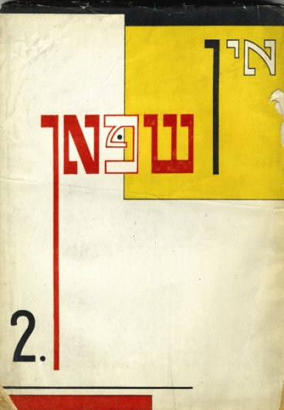

*In shpan* (In Harness), 2 (May 1926), Vilna. This issue features an article by Bergelson, who was a regular contributor. The cover is an example of Constructivist graphic design.

**References and further reading**

Estraikh, Gennady (2005) *In Harness: Yiddish Writer’s Romance with Communism.* Syracuse, NY: Syracuse University Press. A detailed history of Yiddish literary life in Russia and the Soviet Union from 1905 to the mid-1930s.

Krutikov, Mikhail (2001) *Yiddish Fiction and the Crisis of Modernity*, 1905-1914. Stanford, Ca: Stanford University Press. This book offers a comprehensive overview of Yiddish literary creation at a major turning point, between the first Russian revolution of 1905 and the outbreak of the First World War. Bergelson’s early novels, essays, and short stories are analysed within the context of this political and aesthetic crisis.

Murav, Harriet (2011) *Music from a Speeding Train: Jewish Literature in Post-Revolution Russia*. Stanford, Ca: Stanford University Press. Murav’s groundbreaking study offers an insightful analysis of Jewish literary creation (in both Yiddish and Russian) in the Soviet Union: Bergelson’s oeuvre features prominently in the book, alongside other writers such as Peretz Markish, Isaac Babel, or Il’ia Erenburg.

Novershtern, Avraham (2010) ‘Bergelson, Dovid’, *YIVO Encyclopedia of Jews in Eastern Europe*. Retrieved April 18, 2014, from <http://www.yivoencyclopedia.org/article.aspx/Bergelson_Dovid>. A pithy summary of Bergelson’s life and work, by one of the leading specialists of Bergelson.

Rubenstein, Joshua and Naumov, Vladimir (2001): *Stalin’s Secret Pogrom: The Postwar Inquisition of the Jewish Anti-Fascist Committee.* New Haven: Yale University Press. A detailed, well-documented historical account of Stalin’s brutal suppression of Soviet Yiddish culture.

Schachter, Allison (2012) *Diasporic Modernisms: Hebrew and Yiddish Literature in the Twentieth Century.* Oxford, UK: Oxford University Press. Schachter’s groundbreaking study offers a detailed analysis of the ways in which Yiddish and Hebrew writers embraced diaspora as a modernist strategy, within international networks that connected Odessa, Jerusalem, Berlin, and New York. Bergelson’s oeuvre features prominently in this study as a prime example of diasporic modernism.

Sherman, Joseph and Estraikh, Gennady (2007) *David Bergelson: From Modernism to Socialist Realism.* Leeds, UK: Legenda. A collaborative volume offering a comprehensive overview of the recent scholarship on the life and work of Dovid Bergelson. Includes a biography, close readings of his major works, a bibliography, and a translation of Bergelson’s essays *Dikhtung un gezelshaftlekhkayt* (Belles-lettres and the Social Order) and *Dray tsentren* (Three Centers).

**List of major works**

Bergelson, Dovid (1909) *Arum vokzal* (At the Depot). Warsaw: Farlag Progres.

Bergelson, Dovid (1913) *Nokh alemen* (The End of Everything). Vilna: B. Kletskin.

Bergelson, Dovid (1919) ‘Dikhtung un gezelshaftlekhkayt’ (Belles-lettres and the Social Order), Bikher-velt (August 1919). Kiev: Kiever farlag.

Bergelson, Dovid (1921) *Opgang* (Descent). Kiev: Kultur-lige.

Bergelson, Dovid (1926) ‘Dray tsentren’ (Three Centers), *In shpan* 1 (April). Vilna.

Bergelson, Dovid (1932) *Bam Dnyepr* (At the Dniepr) Moscow: Emes.

Bergelson, Dovid (1934) *Birobidzhaner* (People of Birobidzhan). Moscow: Emes.

*Selection of works available in English translation*

Bergelson, Dovid (1999) *Descent.* New York: Modern Language Association of America.

Bergelson, Dovid (2009) *The End of Everything*. A new translation of Bergelson’s 1913 novel by Joseph Sherman, with a substantial introduction to his life and work.

Bergelson, Dovid (2005) *The Shadows of Berlin: the Berlin Stories of Dovid Bergelson.* San Francisco: City Lights Books.

Bergelson, Dovid (1996) *The Stories of Dovid Bergelson: Yiddish Short Fiction from Russia.* Syracuse, NY: Syracuse University Press.

Sherman, Joseph (2012) *From Revolution to Repression: Soviet Yiddish Writing 1917-1952.* Nottingham, UK: Five Leaves. An anthology of Soviet Yiddish fiction. Includes three short stories by Bergelson.

Wisse, Ruth (ed.) (1986) *A Shtetl and other Yiddish Novellas*. Detroit: Wayne State University Press. Includes a translation of Bergelson’s short story *Arum Vokzal* (At the Depot).

URLs of Illustrations

Portrait of Bergelson:

[https://www.google.com/search?q=dovid+bergelson&client=firefox-a&hs=4RQ&rls=org.mozilla:en-US:official&source=lnms&tbm=isch&sa=X&ei=ZQ87U5nLJaGGyAHru4HQBw&ved=0CAkQ_AUoAg&biw=747&bih=344&dpr=1.71#facrc=_&imgdii=_&imgrc=U2xLOA7ejd2aVM%253A%3B9iUKK9eQvsmUVM%3Bhttps%253A%252F%252Ffbcdn-photos-a-a.akamaihd.net%252Fhphotos-ak-ash2%252F25198_363499899124_4478489_a.jpg%253Flvh%253D1%3Bhttps%253A%252F%252Fhe-il.facebook.com%252Fpages%252FDovid-Bergelson%252F279966009124%3B180%3B278](https://www.google.com/search?q=dovid+bergelson&client=firefox-a&hs=4RQ&rls=org.mozilla:en-US:official&source=lnms&tbm=isch&sa=X&ei=ZQ87U5nLJaGGyAHru4HQBw&ved=0CAkQ_AUoAg&biw=747&bih=344&dpr=1.71#facrc=_&imgdii=_&imgrc=U2xLOA7ejd2aVM%253A%3B9iUKK9eQvsmUVM%)

(copyright holder: YIVO Archive?)

Group photo (Markish, Bergelson, Kharik, and Mikhoels): <http://www.tabletmag.com/jewish-arts-and-culture/books/820/back-from-the-shadows>

Copyright holder: YIVO Archive, New York

Cover of Di shpan:

<http://www.kedem-auctions.com/sites/default/files/383_6.jpg>

Copyright holder: Photograph: Kedem auctions (work: YIVO Archive, New York?)

**Raphael Koenig, Harvard University**